
Solution Architecture

Date | 28 June 2026
Team ID | xxxxxx
Project Name | Personalized Networking Assistant
Maximum Marks | 5 Marks

Solution Architecture Diagram:
Provide a high-level visual representation of your solution's architecture. Use the structural layout below as a template to map out your Presentation Layer, Application Layer, and Data Layer. Fill in the specific technologies and components for your project directly into the boxes to create your architectural diagram.
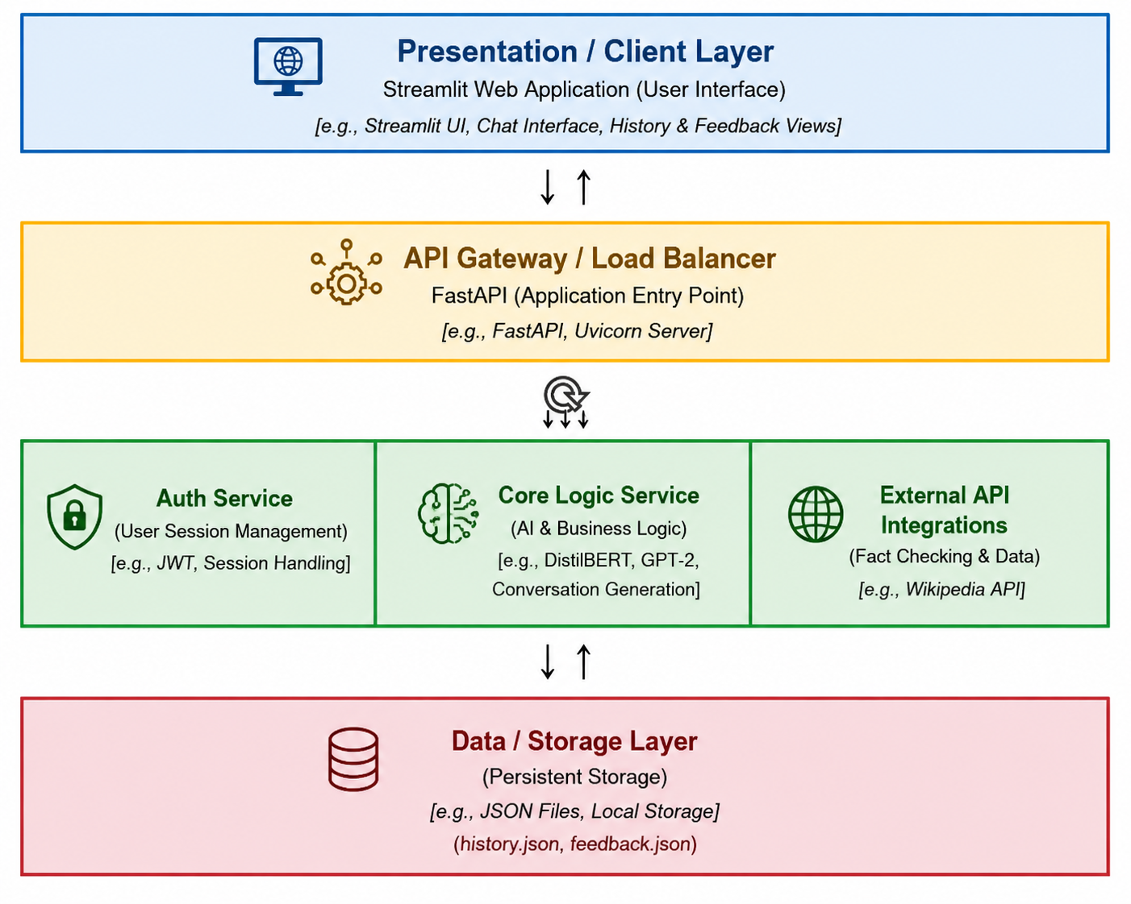


Component Description Table

Component Name | Description / Role in Architecture | Technologies Used
Presentation Layer | Provides the user interface where users enter event details, interests, generate personalized conversation starters, view conversation history, and submit feedback. | Streamlit, HTML, CSS, Python
API Gateway | Acts as the entry point for all client requests. It receives requests from the Streamlit application, routes them to the appropriate services, and returns responses to the user. | FastAPI, Uvicorn
Microservices | Implements the core application logic, including AI-based conversation generation, event analysis, fact verification, history management, and feedback processing. | Python, DistilBERT, GPT-2, Transformers, PyTorch, Wikipedia API
Database | Stores conversation history, user feedback, and application data for future reference and analysis. | JSON Files (history.json, feedback.json), Local File Storage

